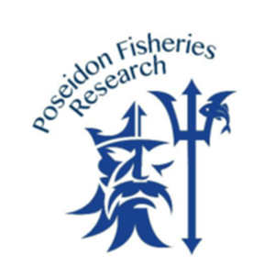Image result for facebook logo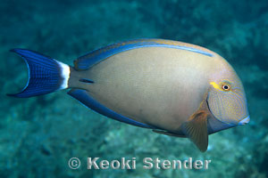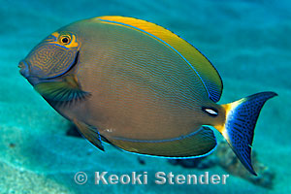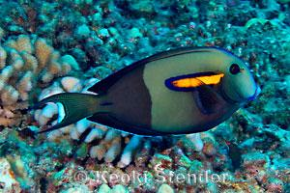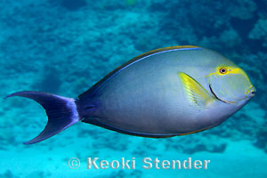

For more information about PFR

Visit [http://poseidonfisheriesresearch.org/](http://poseidonfisheriesresearch.org/?fbclid=IwAR3pKlSy8dhYFg0dButvHmxCc-XaxT-u_kvLG7iI7HrhGrW4N56lJFS90Ps)

@poseidonfisheriesresearch

Call: Cassie 464-6083 or

John 464-6055

**Pualu**

**Na`ena`e**

**Pualu**

**Palani**

**Have you caught any of these fish?**

**You got it? We want it!**

**We’ll clean it and you keep it!**

**Poseidon Fisheries Research** is requesting help from  
local fishermen to collect the following fish:

**Palani, Pualu, and Na’ena’e.** The project aims to

estimate age, growth, and maturity of these fishes.

We are asking members of the fishing community

to help us target fish that are

**Less than 7” and Greater than 16”**

Contribute to the science that will be incorporated in future management decisions for local species!

Photo credit: Keoki Stender (www.marinelifephotography.com)

W A N T E D